Chapter V
European Administration
Supervision of EU administration
The European Administration course (20 teaching hours) is divided to 5 blocks (chapters).
A chapter is designed for 4x45 minutes of studying!
Advices for your individual work:
1. Read the reading material! You may use the additional slideshow to see a graphical version of your reading! By clicking on the hyperlinks, you can get some additional information, or you can refresh your basic knowledge!
2. Try to test your knowledge with the help of the exercises! They help you to process the material in depth and the terms and significant definitions help you to catch up quickly with the mainstream of the material!
3. Do the test of multiple choices for a final check upon your newly gained knowledge!
4. If you have further plan to deepen your knowledge on the issue, the collected literature helps you to step on that path!

Erzsébet CSATLÓS, PhD
INSTITUTE OF PUBLIC LAW, UNIVERSITY OF SZEGED
CSATLÓS.E@HURIS.U-SZEGED.HU

I. Supervision of direct administration 1
1.1. Administrative supervision 2
1.1.1. General supervision by the head of execution 3
1.1.2. Independent supervision within the EU administration 3
1.2. Judicial supervision 5
1.2.1. Action for annulment (Article 263 TFEU) 6
1.2.2. Action for failure to act (Article 265 TFEU) 6
1.2.3 Action for damages against the EU (Article 268 TFEU) 7
1.3. Political Supervision 8
1.3.1. Political supervision through the European Parliament 9
1.3.2. Political supervision through the European Council and the Council 11
1.4. The European Ombudsman 13
II. Supervision of indirect administration 18
2.1. Administrative supervision 18
2.1.1. Domestic administrative supervision 18
2.1.2. EU level supervision of national administrative functioning 0
2.2. Political supervision 2
2.2.1. Petition to the European Parliament 2
2.2.2. Procedure of Article 7 TEU 4
2.3. Judicial supervision 7
2.3.1. Domestic legal remedy for the breach of EU law 7
2.3.2. Member State liability for the breach of EU law before domestic courts 8
2.3.3. Member States liability for the breach of EU law before CJEU: infringement procedure 10

I. Supervision of direct administration

The supervision of administrative action is required by the principles of good administration, of the rule of law, and of democracy (and the separation of powers) to prevent and/or cure maladministration and the abuse of power. Maladministration occurs when a public body fails to act in accordance with a rule or principle which is binding upon it.
Supervision can be interpreted in three different ways: administrative, judicial and political, and there is a distinctive power practiced by the European ombudsperson

1.1. Administrative supervision

Internal or administrative supervision provides the opportunity for the public administration to get, or keep, its house in order to minimize the need for intervention through either the political or judicial branch or through specialised authorities Treaties require the administrative supervision of EU administrative action which includes control by Union authorities over both the EU administration itself and the administrations of the Member States (within the sphere of European law). [291(2) TFEU and Articles 16(1) and 17(1) TEU] Here, first the direct level’s supervision is taken into account.

1.1.1. General supervision by the head of execution

1.1.1.1. Supervision within the Commission

The characteristics of the Commission incorporates a sort of internal control and supervision of the European administration. The lack of a formal hierarchy in the Commission and the nature of the collegiate decision-making of the Commissioners themselves create a strong impetus towards consensus.
The chain of responsibility continues down to department level in the person of the Director- General, who is answerable to the Commissioner and the College for the proper implementation of the guidelines set by the College and the Commissioner and, in particular, for the management of the Directorate-General or Service in line with the distribution of powers as defined by the Staff Regulations, the Financial Regulation, the Rules of Procedure and the rules laid down as part of the administrative and financial reform of the Commission [European Commission, Code of Conduct for Commissioners, 24 November 2004, SEC(2004) 1487/2]

1.1.2. Supervision of agencies

The agencies might be expected to be subject to classical hierarchical supervision. However, the specialized nature of their subject areas suggests that they can sometimes be conceived of as satellite institutions. Their location within supervisory arrangements reflects this also: it would be difficult to regard the agencies uniformly as merely subordinate departments either of the Commission as such, or of any DG. The supervisory
arrangements applying to them are rather varied.
It can be observed that the supervision of agencies relies significantly on anticipatory structural elements (for example, requirements concerning their membership, representation on their governing boards, and involvement in overall policy-setting) rather than on detailed substantive elements (for example, directions or guidance as to the nature of individual decision-making).

Commission control over agencies is thus present in the establishment phase and in relation to a number of broader operational aspects. The Member States and the Commission are represented on the management board, which adopts the agency’s work programme and provides annual reports of the agency’s work. In addition, in the process of adoption of the agency’s work programme the Commission has opportunities to incorporate its views into it. In most instances the Commission has to be consulted before the adoption of the work programme. In some instances, the Commission can object to the programme. The reporting duties of an agency also allow the administrative (and political) institutions of the Union and the Member States to exert pressure on it. Certain agency statutes provide that agency acts can be referred to the Commission for a review of legality or subject to internal review within the agency itself (p. ex. European Centre for the Development of Vocational Training, European Agency for Safety and Health at Work, European Centre for disease prevention and control)

1.1.2. Independent supervision within the EU administration

Specialized and independent supervision is conducted within the EU direct administration
by the
- European Court of Auditors (ECA),
- the European Anti-Fraud Agency (OLAF),
- the European Union Agency for Fundamental Rights (FRA), and
- the European Data Protection Supervisor (EDPS).
It should be noted immediately that OLAF and the Human Rights Agency, as well as the Court of Auditors to a limited extent, have supervisory competences also in regard to administrative action taken by the Member States. Also, certain aspects of the operation of both the Court of Auditors and the EDPS, as well as of OLAF, especially the networks in which they participate and their cooperation with national bodies, link them closely with supervision of or within Member State administrations.

The European Court of Auditors (ECA) is an EU institution established in 1977 but operates as an institution since 1993. Its mission is to contribute to improving EU financial management, promote accountability and transparency, and act as the independent guardian of the financial interests of the citizens of the Union. The ECA’s role as the EU’s independent external auditor is to check that EU funds are correctly accounted for, are raised and spent in accordance with the relevant rules and regulations and have achieved value for money.
The European Anti-Fraud Office (OLAF - Office de la Lutte Antifraude) is a key instrument of internal or administrative supervision of administrative action within the EU. It exists since 1999 but its ancestor was established in 1988. as it is the only EU body mandated to detect, investigate and stop fraud with EU funds. OLAF can investigate matters relating to fraud, corruption and other offences affecting the EU financial interests concerning: all EU expenditure: the main spending categories are Structural Funds, agricultural policy and rural development funds, direct expenditure and external aid; some areas of EU revenue, mainly customs duties; suspicions of serious misconduct by EU staff and members of the EU institutions. The administrative investigations include thus investigations (concerning EU financial interests) in the Member States and those involving staff of the EU institutions. See success stories here.
The European Data Protection Supervisor (EDPS) is an independent data protection authority for the European Union institutions, bodies and agencies, which was first appointed in 2003. The function of the EDPS, in some ways comparable within its scope with the European Ombudsman, is the supervision of personal data processing falling within the scope of EU activities and carried out by Union institutions or bodies, and the ensuring of the compatibility of EU actions with the data protection regulatory framework. It handles complaints from individuals, including EU staff, alleging mishandling of personal data, and the conduct of an enquiry into and reporting upon admissible complaints; its enquiries conducted upon the initiative of the EDPS, where necessary by way of inspection, including both investigations subsequent to resolving single cases and the monitoring of the compliance of EU organizations with legal principles and rules; and it supervises the Eurodac fingerprint database of asylum seekers and illegal EU immigrants. Decisions of the EDPS are reviewable before the CJEU and damages under Article 340 TFEU (Article 288 EC) are available in appropriate cases.
The data protection rules for the EU institutions are laid down in Regulation (EU) 2018/1725. The EDPS carries out its supervision work related to this Regulation. The EU institutions consult EDPS for advice via their Data Protection Officers (DPOs). In some cases, these consultations are mandatory (e.g. prior consultation when EU institutions are not sure about the safeguards identified in a data protection impact assessment or when drawing up internal rules restricting data subjects’ rights), while in others, they are voluntary.
- the EDPS gives written or verbal advice to them either on request or on our own initiative:
  - the written advice is contained in Opinions, comments, Decisions, letters or papers;
  - a general advice is provided on topics that are relevant for all EU institutions in guidelines;
  - verbal advice is offered via DPO telephone hotline (reserved for the EU institutions);
  - offer useful resources and documents to assist DPOs in general, for instance case-law & guidance, in a dedicated section on this website called DPO Corner.
- the EDPS raise awareness about data protection in the EU institutions and provide training;
- the EDPS conduct data protection audits to verify compliance in practice;
Enforcement
When EU institutions do not comply with the data protection rules, the EDPS can use the enforcement powers set out in the Regulation, such as:
- Warn or admonish the EU institution which is unlawfully or unfairly processing your personal information;
- Order the European institution to comply with requests to exercise your rights (e.g. access to your own data);
- Impose a temporary or definitive ban on a particular data processing operation;
- Impose an administrative fine on EU institutions;
- Refer a case to the Court of Justice of the European Union.
Complaints
If a person thinks that his/her rights have been infringed by an EU institution processing your personal information, you can lodge a complaint with the EDPS to investigate it. The EDPS recommends that first he/she shall contact that EU institution to resolve the issue. In many cases, the issue will be solved at that level. The EDPS has no supervisory powers for handling complaints on the processing of personal information by national authorities or private organisations.
From 12 December 2018, under Regulation (EU) 1725/2018 all European institutions and bodies have a duty to report certain types of personal data breaches to the EDPS. Every EU institution must do this within 72 hours of becoming aware of the breach, where feasible. If the breach is likely to pose a high risk of adversely affecting individuals’ rights and freedoms, the EU Institution must also inform the individuals concerned without unnecessary delay.
The European Union Agency for Fundamental Rights (FRA) was founded in 2007 and seated in Vienna. It is an independent decentralized agency for pooling fundamental rights expertise and is an ‘odd one out’ as its the gathering of data relevant to human rights protection, the conduct of academic research, and the submission of both annual and special reports. Arguably it has some supervisory function vis-a`-vis the administration, but this appears to be highly restricted, relating only to consultative or advisory measures. It has no capacity to address complaints or investigate individual cases and cannot make decisions, and so is not comparable with the Ombudsman.

1.2. Judicial supervision

The judicial supervision means the review of EU administrative action by courts of the EU. There are different procedures to that end:
- action for annulment
  - incidental forms of review
    - Plea of illegality under Article 277 TFEU
    - Review of validity under Article 267 TFEU
- action for failure to act
- action for remedy of damages

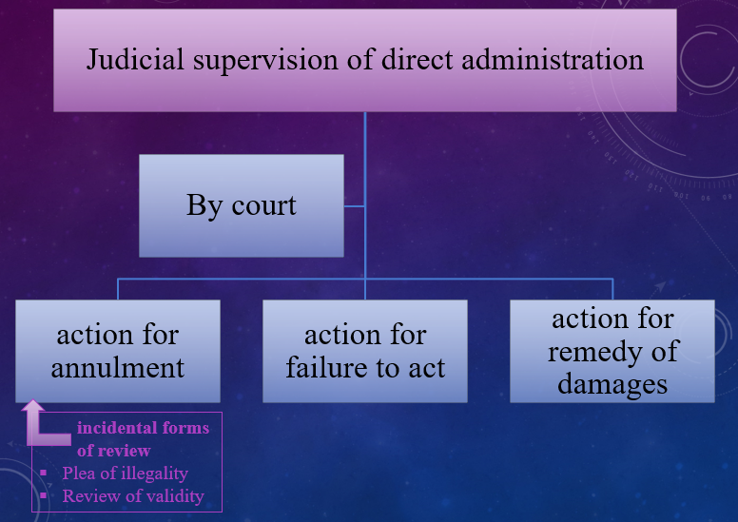

1.2.1. Action for annulment (Article 263 TFEU)

An action for annulment is a legal procedure before the Court of Justice that guarantees the conformity of EU legislative acts, regulatory acts and individual acts with the superior rules of the EU legal order. An action can be brought within 2 months of the publication or notification of the contested measure.

Once the deadline is over, any party may, in proceedings in which an act of general application adopted by an institution, body, office or agency of the Union is at issue, plead the grounds for annulment, in order to invoke before the Court of Justice of the European
Union the inapplicability of that act (plea of illegality)

The CJEU have jurisdiction to give preliminary rulings and while doing so, it has the opportunity, on a reference by a Member State court, to review the validity of an act adopted by Union institutions, bodies, offices, or agencies. (review of validity)

1.2.2. Action for failure to act (Article 265 TFEU)

The original purpose of the action for failure to act was to constitute whether European Union institution properly fulfilled its obligations under the EU legislation. However, in the course of case-law, a mere EU institution’s express refusal to fulfil its duties became sufficient to constitute that the EU institution acted and therefore action for failure to act became devoid of purpose.
The Court of Justice has exclusive jurisdiction over actions brought by a Member State against the EP and/or against the Council or brought by one European Union institution against another. The General Court has jurisdiction, at first instance, in actions brought by individuals.
The action shall be admissible only if the institution, body, office or agency concerned has first been called upon to act. If, within two months of being so called upon, the institution, body, office or agency concerned has not defined its position, the action may be brought within a further period of two months.
Any natural or legal person may, under the conditions laid down in the preceding paragraphs, complain to the Court that an institution, body, office or agency of the Union has failed to address to that person any act other than a recommendation or an opinion.

1.2.3 Action for damages against the EU (Article 268 TFEU)

The EU shall make good any damage caused by its institutions or by its servants in the performance of their duties. It is clear from this provision that an action cannot be brought against an institution of the Union itself, but against the Union represented by the institution or institutions whose action allegedly caused the damage. It was jurisprudence that established the criterion system of the action.
It is an independent remedy, not conditional on the earlier successful pursuit of a different cause of action. any action for damages in the area of Common and Foreign Security Policy, under the Lisbon Treaty it has recognised its ability to rule on damages regarding restrictive measures adopted by the EU (Case C-239/12 P Abdulrahim).
The General Court has jurisdiction to hear and determine actions seeking compensation for damage caused by the institutions or the bodies, offices or agencies of the European Union or their staff.

1.2.3.1. Who is entitled to bring an action for damages?

Any natural or legal person, under public or private law, established in the EU or not, is eligible to bring action
Article 340 TFEU does not specify who may bring an action for damages. However, the EU Charter specifies that the right to damages is granted to 'every person', i.e. any natural or legal person. Ont he othr side, the defentant is the EU an EU institution may not bring an action for damages against another EU institution as, in legal terms, the defendant is the European Union as such.

1.2.3.1. The question of liability

a) Joint liability of the EU and Member States is possible
Since most EU law is either implemented through national legislation (and then applied by national administrations) or directly applied by national administrations, the wrongful implementation and application of otherwise legal EU action may be ascribed exclusively to the Member States, making them liable for public torts. However, if damage is caused jointly by an illegal action of the EU and one or several of its Member States, shared (concurrent) liability of both may be established. This occurs if 'it was illegal to delegate implementation to the Member State in the first place, or when Member States are liable for the implementation of a wrongful [EU] act'. Were a Member State to be held liable for damages vis-à-vis an individual for implementing or applying EU law, this Member State could claim repayment of such damages from the EU and, in the event of non-payment, bring an action for damages. However, no such case has, as yet, been brought.

b) Liability for unlawful discretionary acts
In the case of discretionary acts, i.e. those that the EU institutions adopted with a certain margin of discretion, the so-called Schöppenstedt formula applies: the applicant must show 'sufficiently flagrant violation of a superior rule of law for the protection of the individual’.

c) Liability for unlawful non-discretionary acts
In the case of non-discretionary acts, a mere breach of law (even if it is not 'sufficiently serious') should be sufficient to obtain compensation from the EU. However, the CJEU has interpreted the notion of 'illegality' narrowly, excluding, for instance, an incorrect interpretation of a regulation (cases 19, 20, 25, 30/69 Richez-Parise) or lack of diligence by the Commission in applying EU law (case T-178/98 Fresh Marine).

d) Liability for lawful acts
In its earlier case law, the General Court theoretically accepted the possibility of EU liability for lawful acts, under specific circumstances. In Dorsch Consult (case T-184/95), it laid down three requirements for such possible liability:
(1) unusual character of the damage;
(2) special character of the damage; and
(3) the fact that the lawful act was not justified by a general economic interest.

1.3. Political Supervision

Political supervision of administrative activity takes place horizontally between EU institutions and bodies within the concept of institutional balance. It also takes place vertically between Member States and the EU, which mutually control each other’s activities in the realm of the implementation of Union law.
The achievement of accountability through political agents can be seen as considerably limited and somewhat unsystematic in a system constructed in the manner of the European Union.

1.3.1. Political supervision through the European Parliament

The EP has the most extended political supervisory power. These allow it to exercise oversight over other institutions, to monitor the proper use of the EU budget and to ensure the correct implementation of EU law.

- Discussion of working program
The President of the European Parliament has the right to speak at the start of each European Council, setting out Parliament’s position on the subjects to be addressed by the heads of state and government. At the beginning and end of each six-month presidency the President of the Council of the European Union discusses their programme with MEPs in plenary. MEPs can table written and oral questions to the Council and can ask it to initiate new policies.
The Foreign Affairs Council is permanently chaired by the High Representative for Foreign Affairs and Security Policy. They, or a representative, attend plenary debates on foreign, security or defence policy. Twice a year, the High Representative reports to the European Parliament about these policies and their financial implications. [TFEU Articles 14 and 15]
The ECB President presents the bank’s annual report in plenary and takes part in a regular monetary dialogue with Parliament’s Committee on Economic and Monetary Affairs. [TFEU Article 284]
The Court of Auditors presents the annual report on the previous year’s budget to the Council and European Parliament. Based on the report, Parliament decides whether or not to approve the way the Commission handled the EU budget by granting the budget discharge. [TFEU Article 286]
- Appointment of members of the EU organs and authorities
The EP is the steering of administrative action through controls over or influence upon appointments. Central to this is the investiture procedure of the Commission.
The EP has the right to approve and dismiss the European Commission. Since 1994, the future commissioners have been required to appear before an EP hearing. Under the Lisbon Treaty, EU heads of state propose a candidate for Commission President, taking into account the results of European elections. The candidate is elected by the EP. Under the Lisbon Treaty, EU heads of state propose a candidate for Commission President, taking into account the results of European elections. The candidate is elected by the EP. [Article 17(7) TEU]
The EP must be consulted before the President, Vice-President and Executive Board of the European Central Bank (ECB) are appointed by the European Council. [TFEU Article 283]
Parliament must be consulted before the appointment of the members of the Court of Auditors by the Council. [TFEU Article 287]
The EP elects the European Ombudsman. [Article 228]
- Motions of censure and dismissal of members of the institutions and bodies of the EU
The European Parliament’s ultimate sanction in its control over the Commission lies in the possibility of dismissing it through a censure motion. If such a motion is carried, the members of the Commission shall resign as a body and the High Representative of the Union for Foreign Affairs and Security Policy shall resign from the duties that he carries out in the Commission. The motion is carried by a two-thirds majority of the votes cast, representing a majority of the component Members of the EP. No motion of censure may be brought against an individual
Commissioner. So far, none of the eight motions of censure brought before Parliament has been adopted. In 1999, the Santer Commission stepped down before Parliament forced its resignation. The EP ensures democratic control over the Commission, which regularly submits reports to Parliament including an annual report on EU activities and on the implementation of the budget. Once a year, the Commission President gives a State of the Union address to plenary. Parliament regularly invites the Commission to initiate new policies and the Commission is required to reply to oral and written questions from MEPs. [Articles 17(8) TEU and 234 TFEU]
The Ombudsman may be dismissed by the Court of Justice at the request of Parliament in exceptional circumstances. [TFEU Article 228]
- Taking action against EU institutions
Parliament can ask the Court to take action against the Commission or Council if they have acted in a way that is contrary to the spirit of EU law. Parliament, together with Council, can ask the Court of Justice to set up specialised courts. [TFEU Articles 257, 263]
- Reporting
The European Parliament has the right to receive a range of regularly produced reports from EU institutions and bodies, especially from the Commission and, to a limited degree, also from agencies.
After each summit the President of the European Council presents a report to the European Parliament on the outcome.
The Ombudsman reports to the European Parliament and presents an annual report to MEPs. [TFEU Article 228]
- Questioning
EP has the right to put questions to the Commission, to which the Commission is obliged to ‘reply orally or in writing’. [Article 230 TFEU]
- Investigations by committees of inquiry
The Parliament has inter alia the right at the request of at least one-quarter of its component Members, to set up a temporary committee of inquiry. It may within the precisely specified subject of the inquiry, investigate alleged contraventions of European law or alleged maladministration in its application in 12 months. [Article 226 TFEU]
- The Petitions Committee of the European Parliament
Any citizen of the EU and to natural and legal persons resident or registered in a Member State has the right to address a petition to the Parliament on a matter within the EU’s fields of activity and affecting him, her, or it directly. [Articles 24 and 227 TFEU]
- Investigations by committees of independent experts
The European Parliament may set up, either alone or in cooperation with other institutions, ad hoc committees of inquiry. The members of these may be either MEPs or external experts, or both. Committees of independent experts are a particular form of investigatory committee, well suited to provide independent advice. In that light one may ask why an institution such as the EP would resort to an external independent group of experts to oversee the Commission in regard to very prominent allegations of mismanagement, instead of resorting to a formally acknowledged parliamentary committee of inquiry or to the European Ombudsman.

1.3.2. Political supervision through the European Council and the Council

Both the European Council and the Council have prerogatives allowing them to exercise both ex ante and ex post political supervision over other EU institutions and bodies in exercising administrative functions: it is related to the institutional relationship, the appointment of persons and actions or measures taken in the exercise of responsibilities.

1.3.2.1. The European Council as political supervisor

The political leader of the EU, the European Council exercises ex ante supervisory powers over the Commission via the appointment procedure of the Commission’s President and Members. [Article 17(7) TEU]
Taking into account the elections to the European Parliament and after having held the appropriate consultations, the European Council, acting by a qualified majority, shall propose to the EP a candidate for President of the Commission. This candidate shall be elected by the EP by a majority of its component members. If he does not obtain the required majority, the European Council, acting by a qualified majority, shall within one month propose a new candidate who shall be elected by the European Parliament following the same procedure. The President, the High Representative of the Union for Foreign Affairs and Security Policy and the other members of the Commission shall be subject as a body to a vote of consent by the European Parliament. On the basis of this consent the Commission shall be appointed by the European Council, acting by a qualified majority.

1.3.2.2. The Council of the European Union as a political supervisor

The Council, the institution representing Member State interests, also takes part in the ex-ante political supervision of the newly formulating Commission. By common accord with the President-elect, shall adopt the list of the other persons whom it proposes for appointment as members of the Commission. They shall be selected, on the basis of the suggestions made by Member States.
The Council possesses ex post supervisory powers vis-a`-vis the Commission in regard to controlling the behaviour the Commissioners urging them to behave with integrity and discretion. Articles 245 and 247
TFEU
The Commissioners shall refrain from any action incompatible with their duties. Member States shall respect their independence and shall not seek to influence them in the performance of their tasks. The Commissioners may not, during their term of office, engage in any other occupation, whether gainful or not. When entering upon their duties they shall give a solemn undertaking that, both during and after their term of office, they will respect the obligations arising therefrom and in particular their duty to behave with integrity and discretion as regards the acceptance, after they have ceased to hold office, of certain appointments or benefits. If any Member of the Commission (a) no longer fulfils the conditions required for the performance of his duties or (b) if he has been guilty of serious misconduct, the CJEU may, on application by the Council acting by a simple majority or the Commission, compulsorily retire him.
In the event of any breach of obligations, the CJEU may, on application by the Council acting by a simple majority or the Commission, rule that the Member concerned be, according to the circumstances, either compulsorily retired or deprived of his right to a pension or other benefits in its stead.
Apart from the Commission, the Council has rights to appoint officials exercising high-ranking functions within authorities active in the administrative sphere. For example, the Council appoints the Members of the Court of Auditors after their nomination by the Member States and a hearing before the EP or nominates key personnel in agencies, for example in Europol.
Further supervisory power is exercised by the rights to confirm or establish rules of procedure and other internal regulatory provisions.
The Council has, like the Parliament, the possibility of obtaining information concerning these bodies through reporting duties and of controlling their financial and personnel resources.
The Council also enjoy a supervisory role with respect to implementing powers delegated to the Commission both in regard to delegated acts and in the framework of comitology procedures (implementing acts).

1.3.3. Political supervision by Member States

A consideration of political supervision of administrative activity through the Member State level needs to focus both on national governmental action on the European level and on the activity of administrations within Member States in the implementation of European law. These involve mechanisms of both ex ante and ex post supervision.
With respect to the former, Member States are able to supervise administrative activity on the Union level through their representatives in the Council.
In many Member States, European affairs had originally been regarded as foreign policy matters, in which traditionally the executive would have a wide discretion. Given the increasing ‘Europeanization’ of nearly every policy area, this view has come to be less and less accepted. Consequently, Member States have struggled to develop mechanisms for the supervision of European matters through their national and sub-national parliaments. Since the Treaty of Amsterdam, rules exist on the European level to ensure that the national parliaments are given information to be able to exercise the desired scrutiny in a timely and informed fashion, scrutiny largely oriented towards legislative acts of the Union. This approach has continued under the Treaty of Lisbon, with declarations that national parliaments contribute to the good functioning of the EU inter alia by being informed about draft legislative acts [Article 12(a) TEU], by ensuring compliance in accordance with the Protocol on the Role of National Parliaments in the European Union and the Protocol on the principles of subsidiarity and proportionality [Articles 5(3), 12(b) TEU and Article 69 TFEU] in respect of the area of freedom, security, and justice), and by ‘by taking part in the inter-parliamentary cooperation’ between national parliaments and with the EP [Article 12(f) TEU].
Amongst the ex-ante possibilities for supervision, participation in the new—enforceable—subsidiarity control as provided for in the Protocol might be regarded as enhancing the role of national parliaments on both the extent and conditions of the delegation of implementing powers to EU institutions. That subsidiarity control mechanism, however, is rather cumbersome in that comments on a draft legislative act are sent to the Commission (or any other institution or body which, in the specific case, may have initiated the legislative proposal) which is then obliged to reconsider the draft where one-third of all national parliaments vote in favour of such a motion.
With respect to national parliaments’ possibility of cooperating among themselves and with the European Parliament, the Treaty provisions seek to enhance the coordination of efforts of political supervision both of the Member State executives in the Council and of their national bodies implementing European law. A forum for such cooperation has been established by members of the European affairs committees of the national parliaments and MEPs who regularly hold meetings within the framework of ‘The Conference of European Affairs Committees’ (Conference des organes specialise´s en affaires communautaires (COSAC)). The meetings of COSAC serve not only to exchange information but also to coordinate efforts of political supervision through concerted action between the parliaments. COSAC will continue to be an important forum for exchanges between parliaments concerning the methodology and substance of parliamentary supervision of executive activities.
The Treaty of Lisbon also makes some provision for the direct involvement of national parliaments in the supervision of European agencies and their administrative activities.
Articles 85(1), third paragraph, and 88(2), third paragraph TFEU, for example, require that legislative acts lay down the procedures for ‘the evaluation of Eurojust’s activities’ and ‘for scrutiny of Europol’s activities’ by not only the European Parliament (as noted above) but also by national parliaments.

1.4. The European Ombudsman

The European Ombudsman is an independent and impartial body that holds the EU’s institutions and agencies to account and promotes good administration.
The Ombudsman shall be elected after each election of the European Parliament for the duration of its term of office. The Ombudsman shall be eligible for reappointment. The Ombudsman may be dismissed by the Court of Justice at the request of the European Parliament (a) if (s) he no longer fulfils the conditions required for the performance of his/her duties or (b) if (s)he is guilty of serious misconduct. The Ombudsman shall be completely independent in the performance of his/her duties. In the performance of those duties (s)he shall neither seek nor take instructions from any Government, institution, body, office or entity. The Ombudsman may not, during his/her term of office, engage in any other occupation, whether gainful or not. [Article 228 TFEU]
The Ombudsman helps people, businesses and organisations facing problems with the EU’s administration by investigating complaints about maladministration by EU institutions and bodies, but also by proactively looking into broader systemic issues.
Maladministration occurs if an institution or body fails to act in accordance with the law or the principles of good administration or violates human rights. Maladministration can include
- administrative irregularities,
- unfairness,
- discrimination
- the abuse of power
- the failure to reply,
- the refusal or unnecessary delay in granting access to information in the public interest.
Complainants do not have to have been affected by the issue(s) complained about.
The Ombudsman shall conduct inquiries for which (s)he finds grounds, either on his/her own initiative or on the basis of complaints submitted to him/her direct or through a Member of the EP, except where the alleged facts are or have been the subject of legal proceedings. Where the Ombudsman establishes an instance of maladministration, (s)he shall refer the matter to the institution, body, office or agency concerned, which shall have a period of 3 months in which to inform him of its views. The Ombudsman shall then forward a report to the EP and the institution, body, office or agency concerned. The person lodging the complaint shall be informed of the outcome of such inquiries.
The Ombudsman shall submit an annual report to the EP on the outcome of his inquiries.
The European Ombudsman cannot investigate complaints against national, regional or local administrations in the Member States, even when the complaints are about EU matters. A complaint must be made within 2 years of the date when the person affected became aware of the facts. The complainant must first have contacted and tried to resolve the matter with the institution in question. The Ombudsman cannot investigate matters that are subject to legal proceedings.
The Ombudsman is not a forum of appeal; therefore, it does not offer legal remedy for the victims of maladministration. The Ombudsman’s role is to investigate and explore maladministration at direct level of European administration that roots in either a bad legal practice, i.e. interpretation of EU law and/or the lack of proper and clear ruling.
The main areas that falls under his/her investigations are the following:
- ensuring EU bodies guarantee the transparency of the EU’s decision-making process, including public access to documents and information, as well as the role of lobbying;
- making sure EU institutions account for and properly explain decisions and reply to people seeking clarifications. Guaranteeing citizens’ rights to participate in the EU’s decision-making process, including language rights and accessibility, and the proper functioning of public consultations and the European Citizens’ Initiative (accountability and inclusive decision-making)
- ensuring the highest ethical standards are maintained by EU officials;
- verifying that the EU’s institutions and bodies manage funding programmes and tenders for which they are responsible, and deal with funding partners and contractors in a fair and procedurally correct manner (management of EU public money)
- ensuring that the EU’s institutions and bodies guarantee fundamental rights in their work;
- ensuring good administration in administrative procedures and practices;
- ensuring respect for right and working conditions of staff members in the EU’s institutions and agencies and respect of rights of those seeking employment with the EU (personnel issues).
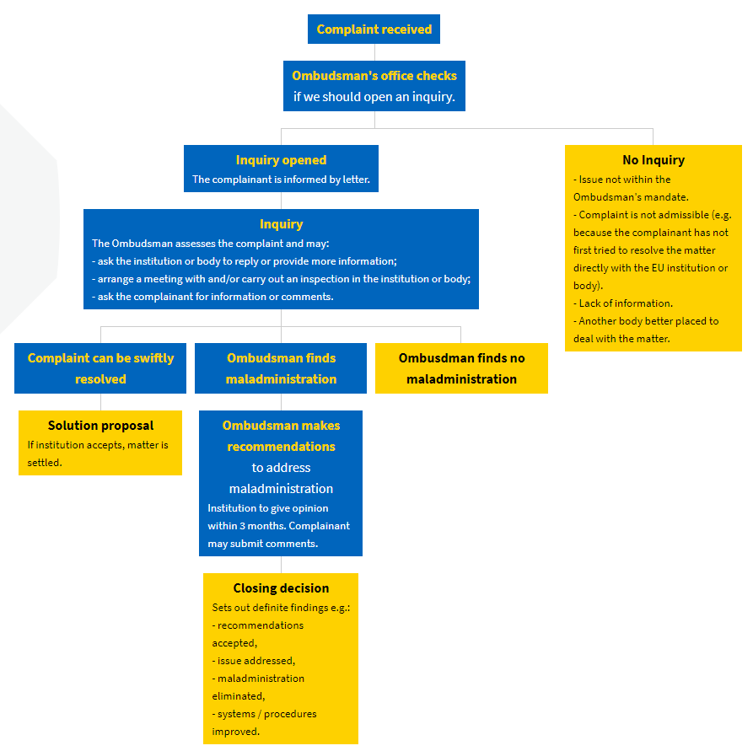
1. A rough outline of the process by which the Ombudsman deals with complaints. Source: https://www.ombudsman.europa.eu/en/complaint-process-guide
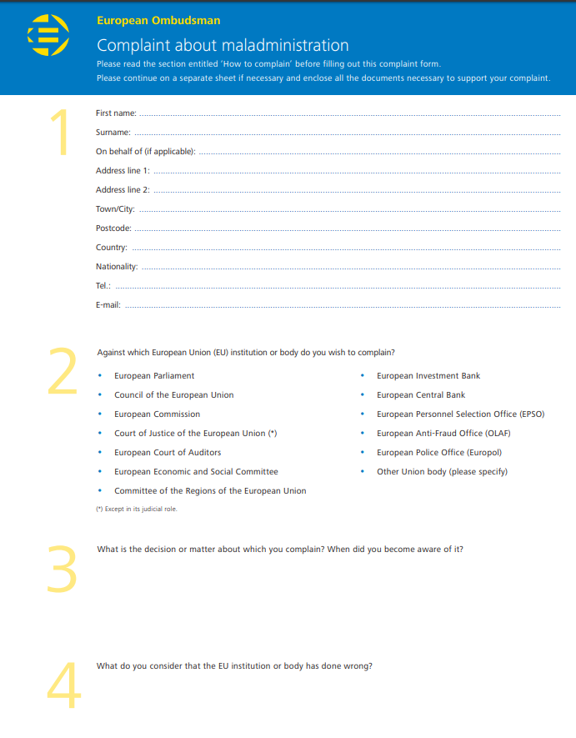
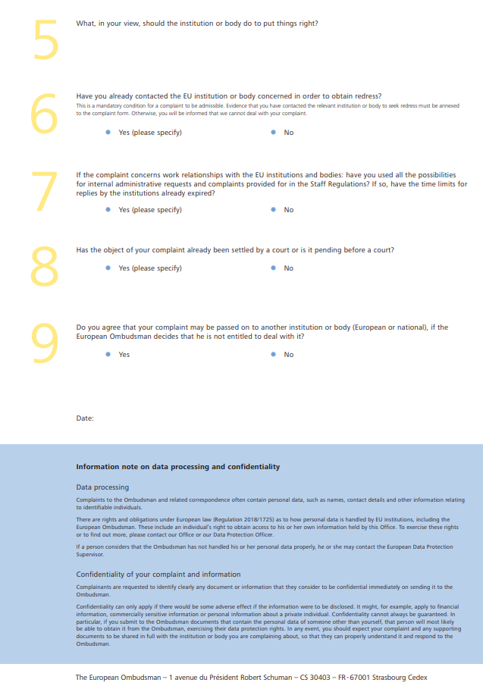
2. Complaint form. Source: https://www.ombudsman.europa.eu/en/make-a-complaint

II. Supervision of indirect administration

By virtue of Article 4(3) TEU, all the authorities of the Member States, including the administrative and judicial bodies, must ensure the observance of the rules of European Union law within the sphere of their competence. Since the Union does not have procedural law or law governing sanctions of its own, it is for the domestic legal system of each Member State to designate the responsible authorities, courts and tribunals having jurisdiction and to lay down the detailed procedural rules governing actions for safeguarding rights which individuals derive from Union law.
Given the fact that the administrative cooperation phase is often not regulated by legal acts, the supervision is a challenging issue: it definitely falls beyond the jurisdiction of national organs and where soft law guidance and other similar sort of documents give indication for the cooperation, the source of obligations is questionable so as the jurisdiction of EU courts.

2.1. Administrative supervision

2.1.1. Domestic administrative supervision

2.1.1.1. Member States’ own administrative system

Members States has their own public administration with or without internal (administrative) appealing system. Judicial review of administrative acts is a general requirement of democratic states which is stemming from the controlling mechanism of the separated branches of power (judicial and executive).
Being the authorities and organs of the EU when the EU law is applied, the Member States’ administrative authorities and judicial organs (tribunals, courts) shall ensure the execution and evaluation of EU citizens’ rights and obligations according to the above-mentioned principles: in view of the procedural autonomy of Member States but ensuring the equivalency, effectiveness, consistent interpretation and the effective legal protection. All in all, with respect to infringements of EU law, the national authorities must proceed with the same diligence as that which they bring to bear in implementing corresponding national laws. [68/88 Commission v Greece, para 25.]

2.1.1.2. SOLVIT – internal market problem solving mechanism

SOLVIT is a service provided by the national administration in each EU country and in Iceland, Liechtenstein and Norway. It was established to deal with cross border internal market problems by addressing specific issues arising from the engagement of EU citizens and businesses with national authorities without recourse to legal proceedings in 2002. With simpler words, it aims to help to solve a problem when the EU citizen feels that his/her rights of EU law are breached by application of EU law by an authority of a Member State outside his/her own State of nationality. SOLVIT is free of charge.

The UK continues to be part of the SOLVIT network until the end of the Transition Period (31.12.2020).

It is mainly an online service. Although there is a SOLVIT centre in each country, the best way to contact them is via this website.

SOLVIT aims to find solutions within 10 weeks – starting on the day your case is taken on by the SOLVIT centre in the country where the problem occurred.
SOLVIT can help you when:
- EU rights as a citizen or as business are breached by public authorities in another EU country and
- the case is not (yet) taken to court (although it can help if you’ve just made an administrative appeal).
Submitting a case to SOLVIT doesn’t suspend any formal or administrative deadlines under national law.

The case will be handled by 2 SOLVIT centres:
- the local SOLVIT centre – home centre
- the SOLVIT centre in the country where the problem occurred– lead centre.

Typical issues SOLVIT can help with

- Getting your professional qualifications recognised
- Visa & residence rights
- Trade & services (businesses)
- Vehicles & driving licences
- Family benefits
- Pension rights
- Working abroad
- Unemployment benefits
- Health insurance
- Access to education
- Cross-border movement of capital or payments
- VAT refunds.

Here are some examples of successful procedures of SOLVIT.
An Austrian physiotherapist applied for professional recognition in Portugal. One year later he still had not had a response from the Portuguese authorities. When enquired how things were progressing, he was asked to wait until they called back. This delay was jeopardizing his chances of working in Portugal. He had been offered a job but couldn’t take it without having his professional qualifications recognised. Thanks to SOLVIT Portugal, the physiotherapist obtained the recognition and was able to start working in Portugal. The case was solved within 5 weeks.
A Polish carpenter working in Sweden was told that, to be entitled to full pay as a skilled carpenter, he needed a Swedish language proficiency certificate. SOLVIT contacted the authorities to explain that the carpenter had already worked for over 10 000 hours in Sweden, so the language test was not justified. After passing a written test in Swedish, the carpenter obtained his certificate as a skilled carpenter. SOLVIT also convinced the Swedish authorities to abolish the standard written language test. The case was solved in 12 weeks.
Three Portuguese nurses applied to have their professional qualifications recognised in Spain. Under EU law, the authorities have to respond to the application within 3 months. The deadline passed but still the nurses received no reply. The young women feared their “European dream” would evaporate if they didn’t receive the papers, they needed to be able to accept three job offers in a Spanish hospital. SOLVIT intervened, and their qualifications were recognised in time, so they could start planning their lives in Spain. The case was solved in 2 weeks.
An Austrian student needed an operation while studying in the Netherlands. Under EU rules, she had the right to be treated in the same way as people insured in the Netherlands. This meant that the hospital should have sent the bill directly to her insurer – instead of asking her to pay the bill. SOLVIT pointed out this would be considered discriminatory. The hospital duly corrected the bill and sent it to the relevant Austrian insurance body. The case was solved in 4 weeks.
A Greek national had to be hospitalised when travelling in the Czech Republic. One year later he received an invoice from the hospital concerned for several hundred euros – even though he had presented his European Health Insurance Card (EHIC). The hospital claimed that neither the name nor the gender of the citizen was the same as those indicated on the EHIC. The discrepancy resulted from the translation from Greek into Czech. In addition, the citizen who was originally named after a Greek god of mythology had changed his name. SOLVIT provided the Ministry of Health in the Czech Republic with the necessary explanations and evidence (social security number and birth certificate) to prove that the holder of the EHIC and the person who had been treated in the hospital were one and the same person. After SOLVIT's intervention, the citizen received a full reimbursement of the costs he had paid. The case was solved in 3 weeks.

SOLVIT cannot help
- if a company is having problems with another company
- in a consumer-related problem
- in case of seeking compensation for damages
- if the case is taken to court (due to its informal nature, SOLVIT cannot run in parallel with formal or legal proceedings).

2.1.2. EU level supervision of national administrative functioning

2.1.2.1. Complaint to the Commission

European Commission may be contacted about any measure (law, regulation or administrative action), absence of measure or practice by a country of the European Union that you think is against Union law.
The European Commission can only take up a complaint if it is about a breach of Union law by authorities in an EU country.
If a complaint is about the action of a private individual or body (unless it can be clearly seen that national authorities are somehow involved), it has to be solved at national level (courts or other ways of settling disputes). The European Commission cannot follow up matters that only involve private individuals or bodies, and that do not involve public authorities. If it is difficult to find out exactly which Union law you think has been breached, you can get advice quickly and informally from the Your Europe Advice service, in your own language.
The European Commission will confirm that it has received the complaint within 15 working days. The European Commission will invite to resubmit your complaint in case it was not submitted on the standard complaint form. Within the following 12 months, the European Commission will assess the complaint except for the case when it is complicated or needs further information. the Commission contact the authorities of the country against which the complainant has made the complaint, it will not disclose the identity of the complainant unless you have given your express permission to do so.
- If the Commission find a breach of EU law, it initiates a formal infringement procedure against the country in question.
If the Commission brings the case before the Court of Justice of the European Union, it may take several years for the Court of Justice to hand down its judgment. Judgments of the Court of Justice differ from those of national courts. The Court of Justice delivers a judgment stating whether there has been an infringement of European Union law. The Court of Justice cannot annul a national provision which is incompatible with European Union law, nor force a national administration to respond to the request of an individual, nor order the country to pay damages to an individual adversely affected by an infringement of European Union law. To seek compensation, complainants must still take their case to a national court within the time limit set out in national law.
- If the Commission thinks that the problem could be solved more effectively by any of the available informal or out-of-court problem-solving services, it may propose to you that your file be transferred to those services.
Certain cases can be dealt with by other mechanisms at EU and national level, which are more appropriate. This applies in particular to individual cases of incorrect application not raising issues of wider principle, where there is insufficient evidence of a general practice, of a problem of compliance of national legislation with EU law or of a systematic failure to comply with EU law. In such cases, if effective legal protection is available, the Commission will, as a general rule, direct complainants to the national level (see Communication on the handling of relations with the complainant in respect of the application of Union law).
For instance, in 2017, the Commission closed infringement procedures and complaints in the area of gambling. The Commission did not consider it a priority to use its enforcement powers to promote an EU Single Market in the area of online gambling services. Complaints in the gambling sector can be handled more efficiently by national courts than by the Commission.
- If the Commission decides that the problem does not involve a breach of Union law, it will inform the complainant by letter before it closes the file.

2.2. Political supervision

A consideration of political supervision of administrative activity through the Member State level needs to focus both on national governmental action on the European level and on the activity of administrations within Member States in the implementation of European law. These involve mechanisms of both ex ante and ex post supervision.
With respect to political supervision within the Member States of national administrative action for the implementation of European law, Member States have very different internal forms of organization, some with strong regional structures vested with original constitutional powers of their own. In respect of the implementation of European law and other administrative activity related to it, the national variants of political supervision of the public administration thus need to be adapted to the particularities of the situation in each Member State.

2.2.1. Petition to the European Parliament

It is one of the fundamental rights of European citizens to turn to the European Parliament and register a petition with a complaint on the application of EU law (Article 227 TFEU).
Any citizen of the European Union, or resident in a Member State, may, individually or in association with others, submit a petition to the European Parliament on a subject which comes within the European Union’s fields of activity and which affects them directly. Any company, organisation or association with its headquarters in the European Union may also exercise this right of petition, which is guaranteed by the Treaty.
The subject of the petition must relate to a matter which comes within the Union’s field of activity. This might for example concern:
- rights as a European citizen as set out in the Treaties;
- environmental matters;
- consumer protection;
- free movement of persons, goods and services;
- internal market; employment issues and social policy;
- recognition of professional qualifications; other problems related to the implementation of EU law.

A petition may take the form of a complaint or a request and may relate to issues of public or private interest.
A petition should be comprehensive and include all facts relating to the issue but should omit unnecessary detail. It should be written clearly and legibly and may be accompanied by a summary. It should not contain offensive or obscene language. For a petition to be admissible, you must be a citizen/resident or, in the case of a legal person, have your registered office in a Member State, the issues raised in the petition must come within the European Union’s fields of activity and must also affect the petitioner(s) directly.
Petitions written illegibly or lacking clarity will be declared inadmissible. A petition must be written in one of the official languages of the European Union.
Requests for information are not dealt with by the Committee on Petitions of the European Parliament, nor are general comments on EU policy.
On 19 February 2020, for example, Members discuss three petitions highlighting the pollution and deterioration of the ecosystem in the Mar Menor lagoon in Murcia, Spain, caused by intensive farming and the activity of wastewater treatment plants. The petitioners emphasize the ecological importance of Mar Menor, a wetland protected under several conservation initiatives, and call on the adoption of urgent measures aimed at reversing the eutrophication of the water and the degradation of the environment.

The petition may present an individual request, a complaint or observation concerning the application of EU law or an appeal to the European Parliament to adopt a position on a specific matter. Such petitions give the European Parliament the opportunity of calling attention to any infringement of a European citizen’s rights by a Member State or local authorities or other institution.
Depending on the circumstances, the Committee on Petitions may:
- ask the European Commission to conduct a preliminary investigation on the petition and provide information regarding compliance with relevant EU legislation;
- refer the petition to other European Parliament committees for information or further action (a committee might, for example, take account of a petition in its legislative activities);
- in some exceptional cases, prepare and submit a full report to be voted on by the European Parliament in plenary, or conduct a fact-finding visit to the country or region concerned and issue a report containing its observations and recommendations;
- take any other action considered appropriate to try to resolve an issue or deliver a suitable response to the petition;
- when the rights as a citizen or as a business have been breached by public authorities in another Member State, the Committee on Petitions can recommend to contact SOLVIT. The Committee on Petitions does not forward petitions directly to SOLVIT as it should be the choice of the petitioner whether or not to make use of this option.
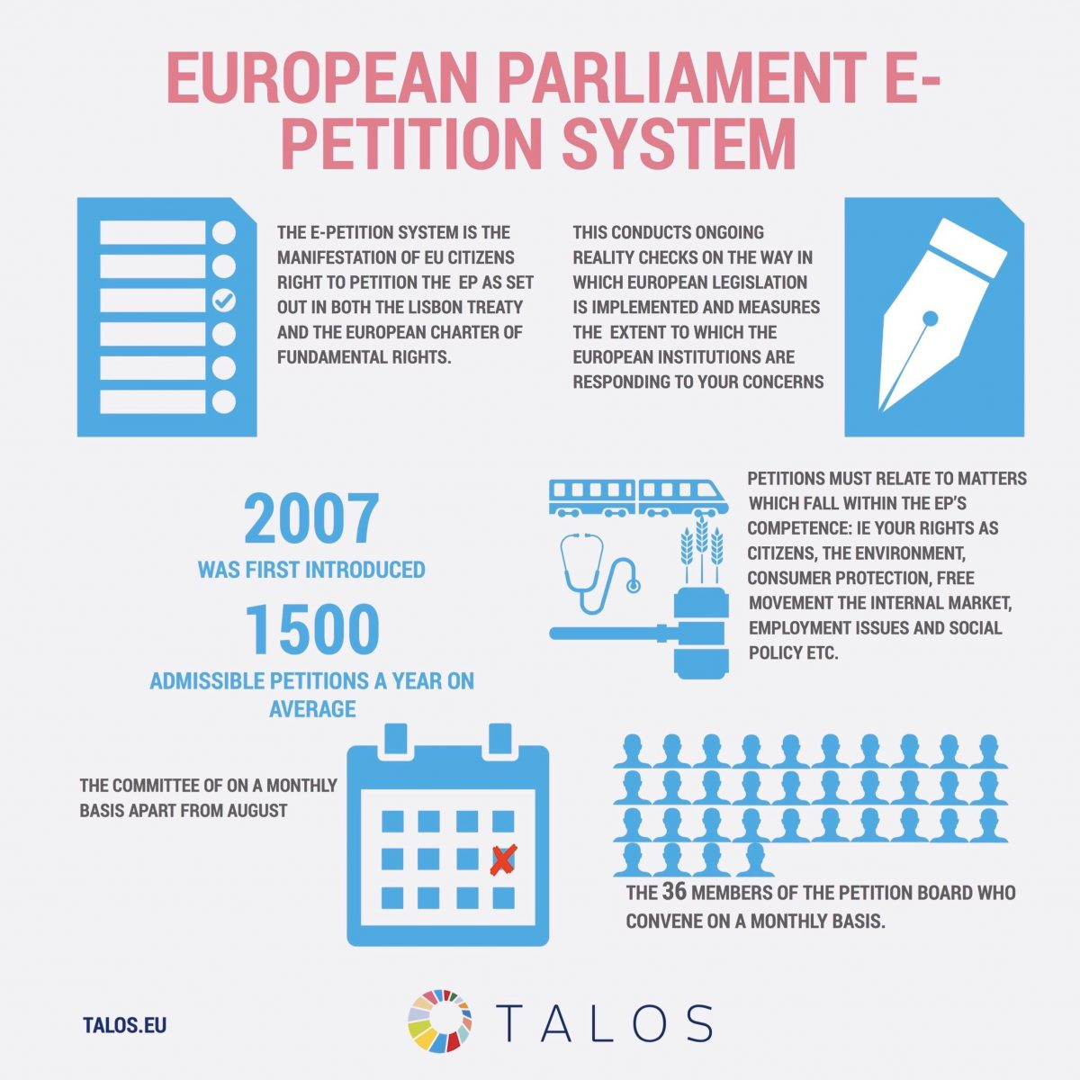

The Committee on Petitions is composed of 35 Members and is headed by a Chairman and 4 Vice-Chairmen. Meetings of the Committee on Petitions take place every month, as a rule, except during the month of August when Parliament is in recess. Whatever is decided, the Committee on Petitions will inform the petitioner as soon as possible in writing after the decision has been made.
The European Parliament cannot overturn decisions taken by the competent authorities of Member States. The European Parliament is not a judicial body and is not empowered to carry out legal investigations, hand down judgments or overturn judgments of Member State courts of law. The European Parliament is not a court of appeal and has no investigative or sanctionary powers of its own. It is a political assembly, acts as a facilitator for citizens, and may lend political support. If, however, new information strengthening the case of petitioners emerges, they may submit it. The Committee may consider re-opening the case.

2.2.2. Procedure of Article 7 TEU

The procedure is sometimes called the EU's "nuclear option" as it provides for the most serious political sanction that can be imposed on a member country: the suspension of the right to vote on EU decisions.
Article 7 TEU
1. On a reasoned proposal by one third of the Member States, by the European Parliament or by the European Commission, the Council, acting by a majority of four fifths of its members after obtaining the consent of the European Parliament, may determine that there is a clear risk of a serious breach by a Member State of the values referred to in Article 2. Before making such a determination, the Council shall hear the Member State in question and may address recommendations to it, acting in accordance with the same procedure.
The Council shall regularly verify that the grounds on which such a determination was made continue to apply.
2. The European Council, acting by unanimity on a proposal by one third of the Member States or by the Commission and after obtaining the consent of the European Parliament, may determine the existence of a serious and persistent breach by a Member State of the values referred to in Article 2, after inviting the Member State in question to submit its observations.
3. Where a determination under paragraph 2 has been made, the Council, acting by a qualified majority, may decide to suspend certain of the rights deriving from the application of the Treaties to the Member State in question, including the voting rights of the representative of the government of that Member State in the Council. In doing so, the Council shall take into account the possible consequences of such a suspension on the rights and obligations of natural and legal persons.
The obligations of the Member State in question under the Treaties shall in any case continue to be binding on that State.
4. The Council, acting by a qualified majority, may decide subsequently to vary or revoke measures taken under paragraph 3 in response to changes in the situation which led to their being imposed.
5. The voting arrangements applying to the European Parliament, the European Council and the Council for the purposes of this Article are laid down in Article 354 of the Treaty on the Functioning of the European Union.
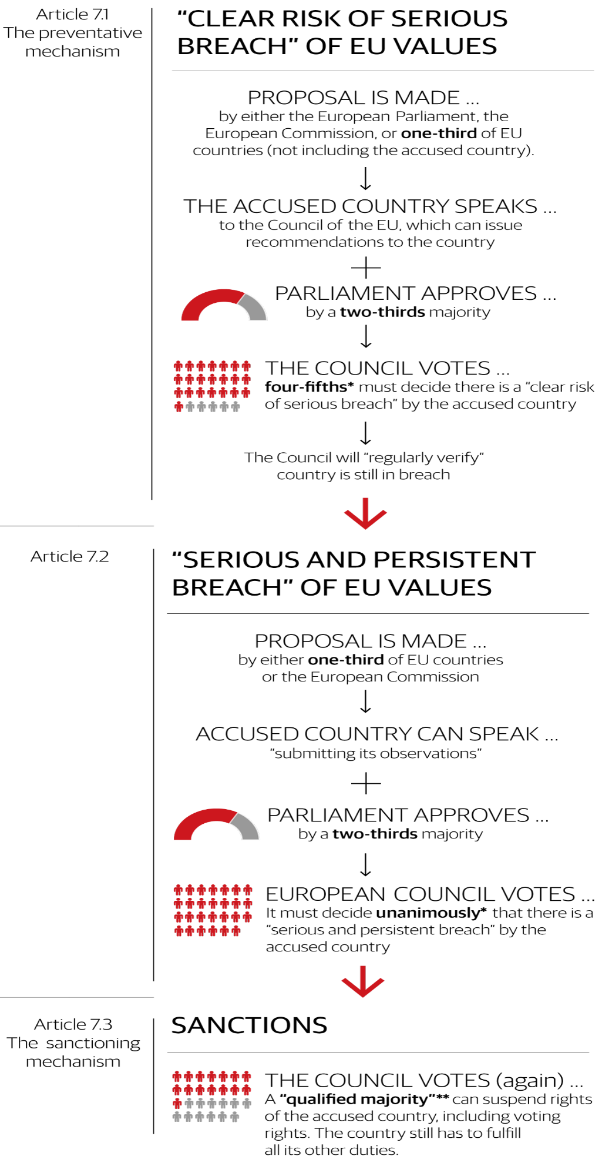
3. *The member of the European Council or of the Council representing the member country in question shall not take part in the vote and the member country in question shall not be counted in the calculation of the one-third or four-fifth of members.
**Qualified majority: 55 percent of EU countries, comprising at least 65 percent of EU population.
Source: https://www.politico.eu/article/graphic-what-is-article-7-the-eus-nuclear-option/

2.3. Judicial supervision

2.3.1. Domestic legal remedy for the breach of EU law

The full effectiveness of Union law is achieved only if individuals can assert before their national courts the rights that they derive from Union law. Accordingly, the Member States are under an obligation to designate the competent court or tribunal to which individuals may apply with a view to protecting the rights which they derive from the application of Union law.
It is a domestic competence to organise the judicial power in a Member State, however, some basic requirements issuing form democracy and the rule of law prevails. The reason behind this is mainly the fact that national judges are EU judges; apart from administration, the national judiciary is also responsible for the enforcement of EU law and to protect the rights inherent.
In connection with tribunal and court procedures, two difficulties may arise.
- First, national rules may impede the effective application of Union law and thereby affect its primacy and direct effect.
- Second, the uniform application of Union law may be jeopardized as a result of diverging national laws. In order to deal with these difficulties,
Art. 4(3) TEU places national courts and tribunals under a duty to ensure the ‘full effectiveness of Union law’ (effet utile). The Court of Justice has defined this duty by means of a number of Union constraints with which national law relating to procedure and sanctions must comply. The principles of equivalence and effectiveness are a practical expression of the principles of the primacy and direct effect of Union law and aim to enable individuals to claim before national courts the full enforcement and protection of the rights which they derive from Union law.
Direct applicability of EU law means that rules of EU law must be fully and uniformly applied in all the Member States. These provisions are therefore a direct source of rights and duties for all those affected thereby, whether Member States or individuals. This consequence also concerns any national court whose task it is as an organ of a Member State to protect, in a case within its jurisdiction, the rights conferred upon individuals by EU law. Furthermore, EU law provisions shall take precedence over conflicting national provisions. Every national court must, in a case within its jurisdiction, apply community law in its entirety and protect rights which the latter confers on individuals and must accordingly set aside any provision of national law which may conflict with it , whether prior or subsequent to the community rule. [106/77 Simmenthal]
If the legal remedy is not effective, the EU law requires judges to take proactive steps.
The asylum application in Hungary of Russian businessman and activist Alexei Torubarov was rejected by the immigration authority of Hungary. He appealed and while a Hungarian court found that Torubarov (a businessman and activist who is suspected of fraud, while he says he is being persecuted) was qualified for asylum, Hungary’s immigration office repeatedly rejected his application. In fact, Hungarian courts lost their right to overrule immigration authorities on asylum applications in 2015, a change spurred by Prime Minister Viktor Orban’s harsh anti-immigration policies, so the authority had the obligation to re-examine the case in the view of the court’s ruling. The authority denied the refugee status again. The complete procedure was repeated three times. Seeing his endless case, a judge from the Pécs Administrative and Labour Court became tired of the authority’s defiance for a third time and, following the suggestion of the Hungarian Helsinki Committee, turned to the CJEU in September 2017. He asked whether the legislation since 2015, which deprived the courts of the substantive decision on granting asylum, complied with EU law.
In 2019, the CJEU has ruled that judges may grant international protection to refugees if an administrative body has overruled their decision without establishing new elements in the case, so it gave back judges’ power in asylum cases in the name of effective judicial protection. Thus, following the preliminary judgment of July 2019 (C–556/17 Torubarov), in September, the Pécs Administrative and Labour Court finally decided to recognise Torubarov as a refugee after six years of pin- pong game between the court and the immigration authority.

Judicial power in the Member States shall be in conformity with the rule of law including independence without any political tension.
Hungary has failed to provide an objective justification for reducing the mandatory retirement age for judges, prosecutors and public notaries from 70 years to 62 years within a time span of only one year. EU rules on equal treatment in employment (Directive 2000/78/EC) prohibit discrimination at the workplace on grounds of age, which also covers a reduction of the retirement for one profession without an objective justification. Following the Commission's letter of formal notice of 17 January, Hungary only proposed a clause that would allow to extend in individual cases the retirement age of a judge beyond 62 if the judge passes a review by the National Judicial Council of his `professional and medical aptitude' and within the limit of a pre-determined annual quota. This proposal does not comply with EU law because such extensions may be arbitrary, apply only in individual cases and they do not address the Commission's main concern: the transitional periods must be sufficiently long to protect the judges' legitimate expectations and avoid the contradictory effect of a sudden drop (in 2012) and then a slow rise (as from 2014) of the mandatory retirement age.

If there is a disagreement on the content of the EU law, the domestic court is empowered to ask a preliminary ruling on the application and interpretation of EU law.
This procedure is considered useful when, in a case before a national court, a question of interpretation which is new and of general interest for the uniform application of EU law is raised, or where the existing case-law does not appear to give the necessary guidance to deal with a new legal situation. The referral must be drafted simply, clearly and precisely given that it will need to be translated to allow other EU countries to submit their observations. [Article 267 TFEU]

2.3.2. Member State liability for the breach of EU law before domestic courts

There is no article in the Treaty, determining neither the concept of the Member States liability in damages for the breach of EU law (hereinafter referred to as state liability in damages) nor the conditions for liability. The possibility to apply this type of liability was established in the practice of the CJEU.
According to the ECJ case law, the state is liable for the acts of its civil servants [C-470/03 A.G.M Cos.MET] and the breaches of law of authorities. The obligation of a Member State to compensate damages for the breach of EU law was recognized by the CJEU years ago [C-60/75, Russo], though all the questions of the recovery of damages were left to national courts.
It was the Francovich case which settled the conditions for Member State liability for the breach of EU law [C-6/90 and C-9/90 Francovich & Bonifaci]
Before the Court’s decision in Francovich neither common definition of the state liability in damages nor conditions for liability were established in the jurisprudence on the Court. A private party could seek the recovery of damages incurred in national courts only in accordance with national legal norms, which were not uniform. Therefore, the standards for the protection of the infringed private parties’ rights were not equal.
“ (…) the EEC Treaty has created its own legal system, which is integrated into the legal systems of the Member States and which their courts are bound to apply. The subjects of that legal system are not only the Member States but also their nationals. Just as it imposes burdens on individuals, Community law is also intended to give rise to rights which become part of their legal patrimony. Those rights arise not only where they are expressly granted by the Treaty but also by virtue of obligations which the Treaty imposes in a clearly defined manner both on individuals and on the Member States and the Community institutions (see the judgments in Case 26/62 Van Gend en Loos [1963] ECR 1 and Case 6/64 Costa v ENEL [1964] ECR 585).
32 Furthermore, it has been consistently held that the national courts whose task it is to apply the provisions of Community law in areas within their jurisdiction must ensure that those rules take full effect and must protect the rights which they confer on individuals (see in particular the judgments in Case 106/77 Amministrazione delle Finanze dello Stato v Simmenthal [1978] ECR 629, paragraph 16, and Case C-213/89 Factortame [1990] ECR I-2433, paragraph 19).
33 The full effectiveness of Community rules would be impaired and the protection of the rights which they grant would be weakened if individuals were unable to obtain redress when their rights are infringed by a breach of Community law for which a Member State can be held responsible.” [C-6/90 and C-9/90 Francovich & Bonifaci para 32-33.]

Member States must apply not the relevant national law, but common conditions for liability elaborated by the CJEU in Factortame II./Brasserie du pêcheur joint cases [C-46/93. and C-48/93. Factortame II/ Brasserie du pêcheur, 51.]
- the rule of EU law infringed must have intended to confer rights on private parties
The first criteria can be established according to various criteria and taking into consideration factual and legal basics of the relevant case. This condition for liability does not restrict the right of the private party to claim compensation from the state.
- sufficiently seriousness of the breach
Sufficient seriousness of the breach is the most restrictive condition for liability, since a private party must prove an infringement, which is a manifest and grave one. The measure of discretion left to a Member State’s authority is no longer a decisive factor for the assessment of the sufficiently seriousness of the breach. For that reason, it must be on every occasion evaluated whether the breach was sufficiently serious—both in wide and no (limited) discretion cases. Therefore, the second condition for liability restricts the right of the private party to obtain reparation.
- direct causal link between the breach and the damage incurred by a private party
The direct causal link must be evaluated according to legal provisions of national law and taking into consideration the principles of effectivenes and equivalence. This condition for liability does not restrict the right of the private party to claim compensation.
The CJEU has no jurisdiction to rule on the lawfulness of a measure adopted by a national authority. Accordingly, it is for the national courts, where appropriate after obtaining a preliminary ruling from the Court, to rule on the lawfulness of the national measure at issue on the same terms on which they review any definitive measure adopted by the same national authority which is capable of adversely affecting third parties and, consequently, to regard an action brought for that purpose as admissible even if the domestic rules of procedure do not provide for this in such a case. [C-97/91 Oleificio Borelli]
Not only damages caused by administrative decisions creates liability but also the decisions of judicial organs of a State may breach EU law for which the Member State is liable towards the individual.
“the Member States are liable to afford reparation of damage caused to individuals as a result of infringements of Community law for which they are responsible is also applicable where the alleged infringement stems from a decision of a court adjudicating at last instance. It is for the legal system of each Member State to designate the court competent to adjudicate on disputes relating to such reparation.” [C-224/01 Köbler 50.]

2.3.3. Member States liability for the breach of EU law before CJEU: infringement procedure

The Commission as the guardian of the Treaties is obliged to monitor the implementation and application of EU law in Member States. It identifies possible infringements of EU law on the basis of:
- its own investigations or
- following complaints from citizens, businesses or other stakeholders, or
- another Member State
It is very rare that a Member State files a complaint on the breach of EU law by another Member State. It happened in the case between Slovakia and Hungary in 2009.
On 21 August 2009, László Sólyom, President of Hungary at the time, sought to enter Slovakia’s territory on the Elizabeth Bridge at Komárom, but he was refused entry by the Slovak authorities. Mr Sólyom was intending to celebrate the festival of Saint Stephen in Komárno (Slovakia) at the invitation of a local Hungarian community association, but he was forced to abandon this plan. Slovakia protested against the visit of the Hungarian head of state; it subsequently argued that the Hungarian President had been seeking to enter Slovakia on a sensitive date. Forty-one years earlier, on 21 August 1968, Warsaw Pact troops – among them Hungarian troops – had invaded Czechoslovakia. Understandably, the events of 21 August 1968 are still painful for Slovakia, and in Hungary it is a source of embarrassment that barely 10 years after 1956, Hungarian troops assisted in the suppression of Czechoslovakia’s nascent democratisation. Therefore, when Sólyom wanted to cross the bridge, ha was refused to enter to the territory of Slovakia. Hungary turned to the CJEU as Slovakia breached the EU law on the free movement of persons and the consecutive directive as the visit of the president of the republic does not fall under any derogation. Slovakia declared that days before the visit the Slovak State had expressed its negative concerns about the visit regarding its political context: the arrival of László Sólyom might have had given rise to a public security risk. Therefore, since the case concerned only the Hungarian head of state’s visit to Slovakia, there was no need to examine further possible restrictions on the right to free movement of other citizens of the Union performing other official duties.
The Court issued its judgment in the Sólyom case on 16 October 2012 (C-364/10 Hungary v Slovakia). The parties to the case were Hungary and Slovakia, but the European Commission also participated as an intervening party in support of Slovakia.
The Court decided that although Slovakia used the wrong justification for the refusal (i.e. the refusal should have taken the form of an authority decision in which the available legal remedy options are invoked), Bratislava had the right to deny entrance to László Sólyom because Sólyom as the president of another country cannot take absolutely private trips abroad. The Hungarian government’s point of view was that Sólyom was denied the free movement of individuals inside the European Union by the Slovak government. However, this right is guaranteed for private persons and the head of state is an official of the State whose visit falls under diplomatic law rules governed by international public law. The CJEU established that the law of diplomatic relations does not fall under the competence of the EU, and so the movement of the heads of state of Member States and their entry into the territory of other Member States is not a field governed by EU law. Further, the Court found that an abuse of rights had not occurred, that a possible future infringement could not be the subject of its judgment, and that it could not interpret EU law.

Once a problem is found, the following procedure takes place.

- Formal procedure
If the EU country concerned fails to communicate measures that fully transpose the provisions of directives, or doesn’t rectify the suspected violation of EU law, the Commission may launch a formal infringement procedure.
The procedure follows a number of steps laid out in the EU treaties, each ending with a formal decision:

- The Commission sends a letter of formal notice requesting further information to the country concerned, which must send a detailed reply within a specified period, usually 2 months.
- If the Commission concludes that the country is failing to fulfil its obligations under EU law, it may send a reasoned opinion: a formal request to comply with EU law. It explains why the Commission considers that the country is breaching EU law. It also requests that the country inform the Commission of the measures taken, within a specified period, usually 2 months.
- If the country still doesn't comply, the Commission may decide to refer the matter to the Court of Justice. Most cases are settled before being referred to the court.

- Court procedure

If an EU country fails to communicate measures that implement the provisions of a directive in time, the Commission may ask the court to impose penalties.
If the court finds that a country has breached EU law, the national authorities must take action to comply with the Court judgment.

- Ex post procedure: non-compliance with a court decision

If, despite the court's judgment, the country still doesn't rectify the situation, the Commission may refer the country back to the court.
When referring an EU country to the court for the second time, the Commission proposes that the court impose financial penalties, which can be either a lump sum and/or a daily payment.
These penalties are calculated according to the provisions laid down in a communication of the Commission and taking into account:
- the importance of the rules breached and the impact of the infringement on general and particular interests
- the period the EU law has not been applied
- the country's ability to pay, ensuring that the fines have a deterrent effect
- The Commission impose financial sanction for the Member State that breaches EU law which is calculated

The amount proposed by the Commission can be changed by the Court in its ruling.
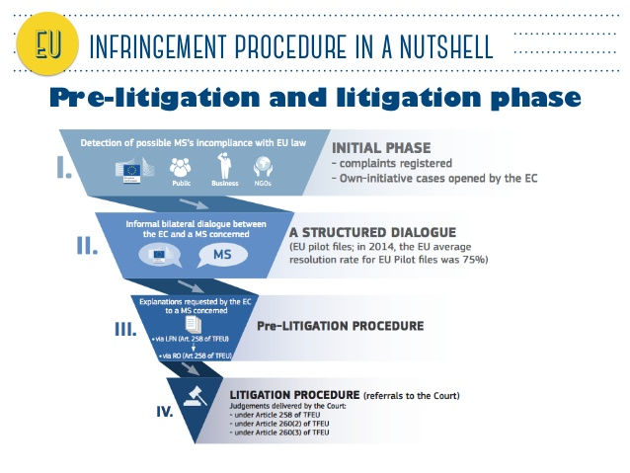

Article 258
If the Commission considers that a Member State has failed to fulfil an obligation under the Treaties, it shall deliver a reasoned opinion on the matter after giving the State concerned the opportunity to submit its observations.
If the State concerned does not comply with the opinion within the period laid down by the Commission, the latter may bring the matter before the Court of Justice of the European Union.
Article 259
A Member State which considers that another Member State has failed to fulfil an obligation under the Treaties may bring the matter before the Court of Justice of the European Union.
Before a Member State brings an action against another Member State for an alleged infringement of an obligation under the Treaties, it shall bring the matter before the Commission.
The Commission shall deliver a reasoned opinion after each of the States concerned has been given the opportunity to submit its own case and its observations on the other party's case both orally and in writing.
If the Commission has not delivered an opinion within three months of the date on which the matter was brought before it, the absence of such opinion shall not prevent the matter from being brought before the Court.
Article 260
1. If the Court of Justice of the European Union finds that a Member State has failed to fulfil an obligation under the Treaties, the State shall be required to take the necessary measures to comply with the judgment of the Court.
2. If the Commission considers that the Member State concerned has not taken the necessary measures to comply with the judgment of the Court, it may bring the case before the Court after giving that State the opportunity to submit its observations. It shall specify the amount of the lump sum or penalty payment to be paid by the Member State concerned which it considers appropriate in the circumstances.
If the Court finds that the Member State concerned has not complied with its judgment it may impose a lump sum or penalty payment on it.
This procedure shall be without prejudice to Article 259.
3. When the Commission brings a case before the Court pursuant to Article 258 on the grounds that the Member State concerned has failed to fulfil its obligation to notify measures transposing a directive adopted under a legislative procedure, it may, when it deems appropriate, specify the amount of the lump sum or penalty payment to be paid by the Member State concerned which it considers appropriate in the circumstances.
If the Court finds that there is an infringement it may impose a lump sum or penalty payment on the Member State concerned not exceeding the amount specified by the Commission. The payment obligation shall take effect on the date set by the Court in its judgment.

LITERATURE

- Catherine Barnard: The Substantive Law of the EU: The Four Freedoms. Oxford University Press, Oxford, 2016.
- Herwig C. H. Hofmann, Gerard C. Rowe and Alexander H. Turk: Administrative Law and Policy of the European Union. Oxford University Press, Oxford, 2011.
- Rui Tavares Lanceiro: The implementation of EU law by national administrations: Executive federalism and the principle of sincere cooperation.
- Dimitry Kochenov: Busting the myths nuclear: A commentary on Article 7 TEU. EUI Working Paper Law, 2017/10. https://cadmus.eui.eu/bitstream/handle/1814/46345/LAW_2017_10.pdf?sequence=1
- The situation in Hungary. European Parliament resolution of 12 September 2018 on a proposal calling on the Council to determine, pursuant to Article 7(1) of the Treaty on European Union, the existence of a clear risk of a serious breach by Hungary of the values on which the Union is founded (2017/2131(INL))

USEFUL WEBSITES
- EUR-lex. https://eur-lex.europa.eu/homepage.html
- The University of Luxembourg’s CVCE.eu research infrastructure (in EN, FR, DE): https://www.cvce.eu/en

SIGNIFICANT TERMS AND DEFINITIONS

Administrative control of administration | internal supervision of administration; administrative organs supervises administrative organ
Judicial control of administration | judicial supervision of administrative organs which issues from the system of the separation of powers
Maladministration | occurs when a public administrative body fails to act in accordance with a rule or principle which is binding upon it
Political control of administration | it means supervision by means of political tools, usually in an ex ante way by influencing or deciding upon the nominations, elections and appointments.

EXERCISES TO TEST YOUR KNOWLEDGE

Find the right feature! One feature may belong to more place!
SOLVIT
OLAF
Infringement procedure
European Ombudsman
EP petition
nuclear option
action for annulment
action for damage against the EU
domestic court procedure

a) political supervision
b) judicial supervision
c) administrative supervision
d) direct level of EU administration
e) indirect level of EU administration
f) may be initiated by individuals before the proceeding organ
g) offers legal remedy
h) rather serves public interest than individual problem solving

TEST OF MULTIPLE CHOICES/QUIZ

1. The European Ombudsman…
a) investigates maladministration in cases when a private person lodges a complaint against an EU authority and obliges the authority to pay financial compensation if it is proven that its procedure failed to respect fundamental rights.
b) investigates maladministration of the Member States administrative authorities if they failed to apply EU law in a proper manner.
c) investigates maladministration of the direct level of EU administrative system but is not a forum for legal remedy.

2. The infringement procedure…
a) is the tool of EU citizens to sue a Member State before the Commission for the breach of EU law.
b) is the tool of EU citizens to sue a Member State before the Commission for the breach of EU law.
c) is the tool of the Commission to sue a Member State before the Court of Justice of the EU for the breach of EU law.

3. The European Parliament offers
a) legal remedy forum for maladministration
b) a forum for petition to call the attention to maladministration which needs investigation.
c) an additional judicial forum for breaches of EU law.

4. The famous Article 7 TFEU
a) is a tool of political control over Member States which seriously violates the values of the EU.
b) is a tool of judicial control over Member States which seriously violates the values of the EU.
c) is a tool of administrative control over Member States which seriously violates the values of the EU.

5. CJEU has no jurisdiction to rule on the lawfulness of a measure adopted by a national authority.
a) Yes, it is always true, it is the duty of domestic courts and judges to decide upon cases (principle of effective legal protection).
b) No, the CJEU is a judicial forum of third instance in case of maladministration at national level.
c) No, the individual can directly file a claim to CJEU – and not to the Member State’s court – if the Member State’s authority issued its decision by applying EU law.

6. The infringement procedure
a) can be initiated by Commission before the Court.
b) can be initiated by the individuals and by any Member States before the Court.
c) can be initiated by the Council of Europe before the Court.

7. The …………are liable to afford reparation of damage caused to individuals as a result of infringements of EU law for which Member State authorities are responsible.
a) Member States
b) EU courts

8. SOLVIT ………………… by the national administration in each EU country and in Iceland, Liechtenstein and Norway if somebody’s rights guaranteed by EU law are breached by public authorities in another EU country.
a) is a legal remedy forum
b) is a service provided
c) is a central EU organ assisted

9. The petition to the EP is a legal remedy.
a) True.
b) False.

10. The European Ombudsman is responsible for the investigation of maladministration in Member States if the authority executes EU law.
a) True.
b) False.

This teaching material has been made at the University of Szeged, and supported by the European Union by the project nr. EFOP-3.6.2-16-2017-00007, titled Aspects on the development of intelligent, sustainable and inclusive society: social, technological, innovation networks in employment and digital economy. The project has been supported by the European Union, co-financed by the European Social Fund and the budget of Hungary.

